Неделя 7 SPL Tokens и Token Extensions
Амангелді Айдос, 3курс, SE
Задание: Создать собственный токен: выпуск, transfer, metadata и взаимодействие через client.
Создание Token-2022 mint через TypeScript-клиент в Solana Devnet. Вывод клиента
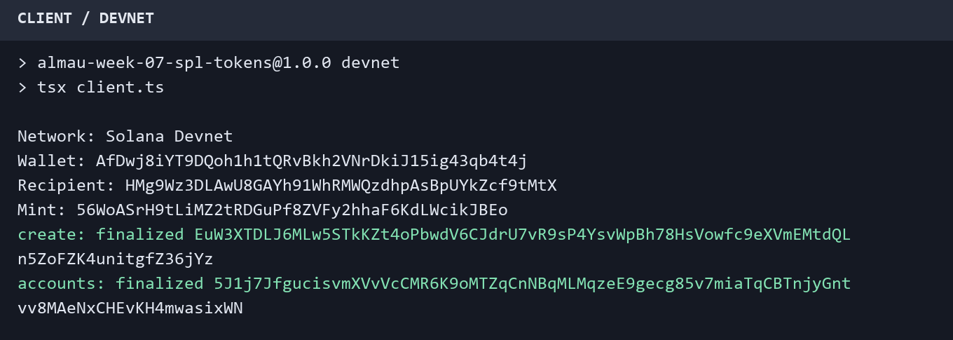
Метаданные токена AIDOS и расширения MetadataPointer и TokenMetadata. Данные SPL Token CLI
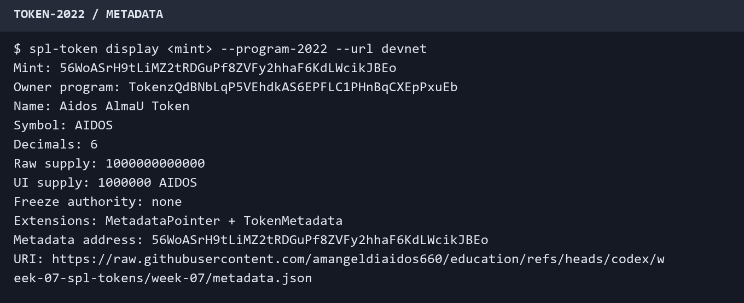
Выпуск 1 000 000 AIDOS и перевод 125 AIDOS через TypeScript-клиент. Вывод клиента
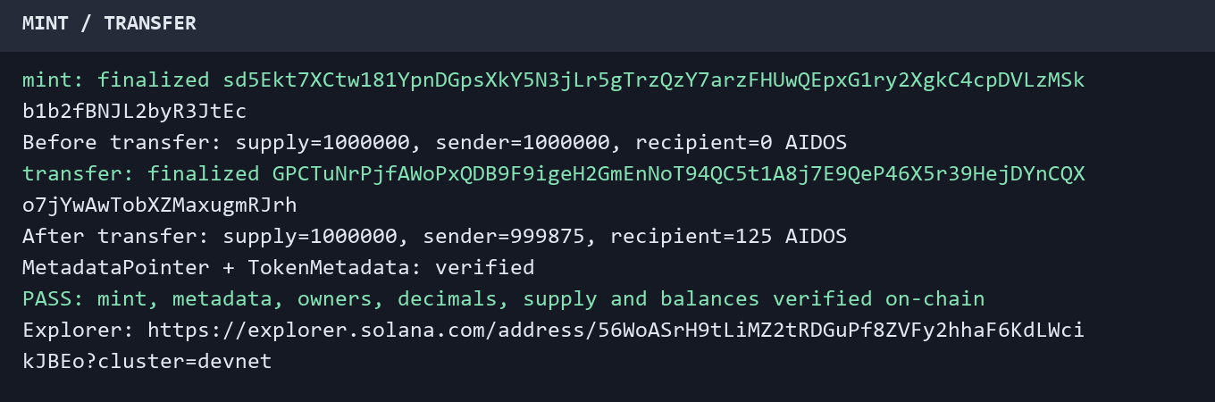
Проверка on-chain состояния и транзакций. Solana Explorer: https://explorer.solana.com/address/56WoASrH9tLiMZ2tRDGuPf8ZVFy2hhaF6KdLWcikJBEo?cluster=devnet
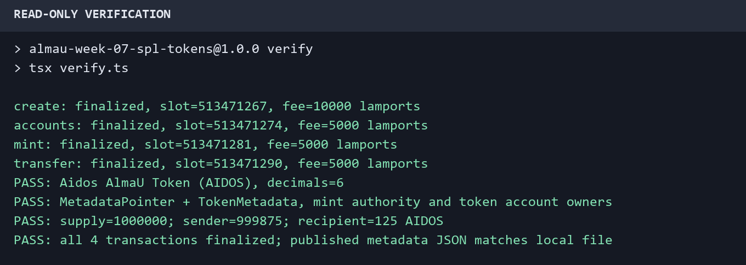
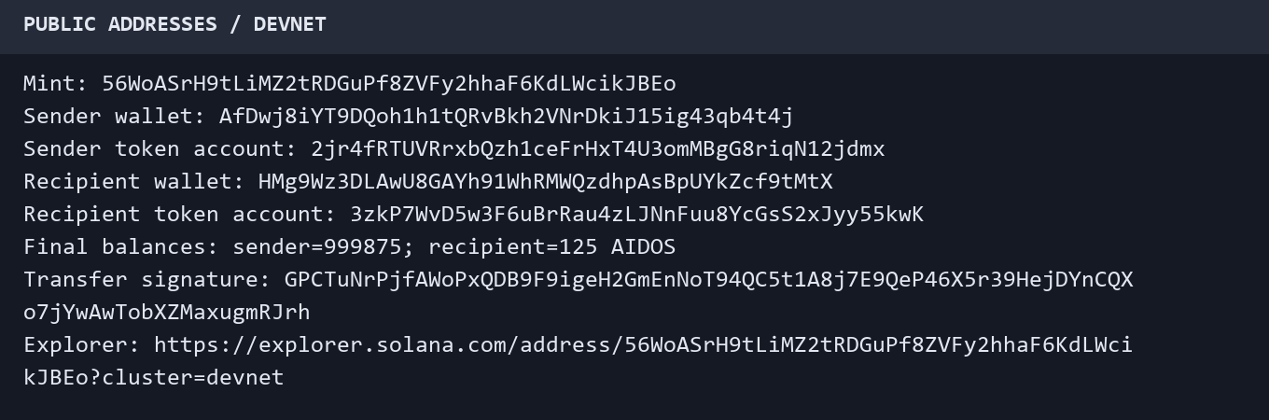

Вывод: создан собственный токен Aidos AlmaU Token (AIDOS) в сети Solana Devnet с использованием Token-2022. Выпущено 1 000 000 токенов с точностью 6 знаков, выполнен перевод 125 AIDOS между двумя кошельками. После перевода баланс отправителя составил 999 875 AIDOS, получателя — 125 AIDOS; общий supply не изменился. В mint добавлены расширения MetadataPointer и TokenMetadata с названием, символом и URI. Все четыре транзакции получили статус finalized. TypeScript-клиент проверил metadata, полномочия, владельцев token account и балансы чтением данных из сети. Исходный код, результаты и отчёт опубликованы в отдельной ветке GitHub.

Репозиторий: https://github.com/amangeldiaidos660/education/tree/codex/week-07-spl-tokens/week-07
Приложение А. Исходный код клиента Token-2022
client.ts
import assert from 'node:assert/strict';
import { mkdir, readFile, writeFile } from 'node:fs/promises';
import {
address, appendTransactionMessageInstructions, createKeyPairSignerFromBytes,
createTransactionMessage, generateKeyPairSigner, getBase64EncodedWireTransaction,
getSignatureFromTransaction, pipe, setTransactionMessageFeePayerSigner,
setTransactionMessageLifetimeUsingBlockhash, signature as signatureFromString, signTransactionMessageWithSigners,
type Instruction,
} from '@solana/kit';
import { getCreateAccountInstruction } from '@solana-program/system';
import {
extension, findAssociatedTokenPda, getCreateAssociatedTokenIdempotentInstruction,
getInitializeMetadataPointerInstruction, getInitializeMint2Instruction,
getInitializeTokenMetadataInstruction, getMintSize, getMintToCheckedInstruction,
getTransferCheckedInstruction, TOKEN_2022_PROGRAM_ADDRESS,
} from '@solana-program/token-2022';
import {
assertDevnet, assertFinal, decimals, inspect, issued, metadata, metadataUri,
rpc, transferred,
} from './shared.js';
await assertDevnet();
assert(process.env.SOLANA_KEYPAIR, 'Set SOLANA_KEYPAIR to your local devnet keypair path');
assert(process.env.RECIPIENT, 'Set RECIPIENT to a different wallet public address');
const secret = JSON.parse(await readFile(process.env.SOLANA_KEYPAIR, 'utf8'));
assert(Array.isArray(secret) && secret.length === 64 && secret.every(n => Number.isInteger(n) && n >= 0 && n <= 255), 'Invalid keypair');
const payer = await createKeyPairSignerFromBytes(Uint8Array.from(secret));
const recipient = address(process.env.RECIPIENT);
assert.notEqual(recipient, payer.address, 'Use distinct wallets');
const local = new URL('.local/', import.meta.url);
await mkdir(local, { recursive: true });
const progressFile = new URL('progress.json', local);
type Progress = { owner: string; recipient: string; mint: string; transactions: Record<string, string> };
let progress: Progress;
let mintSigner;
try {
progress = JSON.parse(await readFile(progressFile, 'utf8'));
assert.equal(progress.owner, payer.address);
assert.equal(progress.recipient, recipient);
} catch (error) {
if ((error as NodeJS.ErrnoException).code !== 'ENOENT') throw error;
mintSigner = await generateKeyPairSigner();
progress = { owner: payer.address, recipient, mint: mintSigner.address, transactions: {} };
}
const mint = address(progress.mint);
const [source] = await findAssociatedTokenPda({ owner: payer.address, mint, tokenProgram: TOKEN_2022_PROGRAM_ADDRESS });
const [destination] = await findAssociatedTokenPda({ owner: recipient, mint, tokenProgram: TOKEN_2022_PROGRAM_ADDRESS });
console.log('Network: Solana Devnet');
console.log('Wallet:', payer.address);
console.log('Recipient:', recipient);
console.log('Mint:', mint);
async function send(label: string, instructions: Instruction[]) {
if (progress.transactions[label]) {
const status = await rpc.getSignatureStatuses([signatureFromString(progress.transactions[label])], { searchTransactionHistory: true }).send();
assert(status.value[0]?.confirmationStatus === 'finalized' && status.value[0].err === null, `Inspect saved transaction ${label} before retrying`);
console.log(`${label}: already finalized ${progress.transactions[label]}`);
return;
}
const { value: lifetime } = await rpc.getLatestBlockhash({ commitment: 'confirmed' }).send();
const message = pipe(
createTransactionMessage({ version: 0 }),
tx => setTransactionMessageFeePayerSigner(payer, tx),
tx => setTransactionMessageLifetimeUsingBlockhash(lifetime, tx),
tx => appendTransactionMessageInstructions(instructions, tx),
);
const transaction = await signTransactionMessageWithSigners(message);
const signature = getSignatureFromTransaction(transaction);
progress.transactions[label] = signature;
await writeFile(progressFile, JSON.stringify(progress, null, 2));
await rpc.sendTransaction(getBase64EncodedWireTransaction(transaction), { encoding: 'base64', preflightCommitment: 'confirmed', maxRetries: 5n }).send();
for (let attempt = 0; attempt < 120; attempt++) {
const { value: [status] } = await rpc.getSignatureStatuses([signature], { searchTransactionHistory: true }).send();
assert(!status?.err, JSON.stringify(status?.err));
if (status?.confirmationStatus === 'finalized') {
console.log(`${label}: finalized ${signature}`);
return;
}
await new Promise(resolve => setTimeout(resolve, 1000));
}
throw new Error(`Confirmation timeout: ${signature}. Check the signature before retrying.`);
}
if (!progress.transactions.create) {
assert(mintSigner, 'Missing mint signer: inspect local progress');
const pointer = extension('MetadataPointer', { authority: payer.address, metadataAddress: mint });
const data = extension('TokenMetadata', {
updateAuthority: payer.address, mint, name: metadata.name, symbol: metadata.symbol,
uri: metadataUri, additionalMetadata: new Map(),
});
const rent = await rpc.getMinimumBalanceForRentExemption(BigInt(getMintSize([pointer, data]))).send();
await send('create', [
getCreateAccountInstruction({ payer, newAccount: mintSigner, lamports: rent, space: getMintSize([pointer]), programAddress: TOKEN_2022_PROGRAM_ADDRESS }),
getInitializeMetadataPointerInstruction({ mint, authority: payer.address, metadataAddress: mint }),
getInitializeMint2Instruction({ mint, decimals, mintAuthority: payer.address, freezeAuthority: null }),
getInitializeTokenMetadataInstruction({ metadata: mint, updateAuthority: payer.address, mint, mintAuthority: payer, name: metadata.name, symbol: metadata.symbol, uri: metadataUri }),
]);
} else {
await send('create', []);
}
await send('accounts', [
getCreateAssociatedTokenIdempotentInstruction({ payer, ata: source, owner: payer.address, mint, tokenProgram: TOKEN_2022_PROGRAM_ADDRESS }),
getCreateAssociatedTokenIdempotentInstruction({ payer, ata: destination, owner: recipient, mint, tokenProgram: TOKEN_2022_PROGRAM_ADDRESS }),
]);
await send('mint', [getMintToCheckedInstruction({ mint, token: source, mintAuthority: payer, amount: issued, decimals })]);
if (!progress.transactions.transfer) {
const before = await inspect(mint, source, destination, payer.address, recipient);
assert.equal(before.supply, issued);
assert.equal(before.source, issued);
assert.equal(before.destination, 0n);
console.log('Before transfer: supply=1000000, sender=1000000, recipient=0 AIDOS');
}
await send('transfer', [getTransferCheckedInstruction({ source, mint, destination, authority: payer, amount: transferred, decimals })]);
const balances = await inspect(mint, source, destination, payer.address, recipient);
assertFinal(balances);
const result = {
network: 'devnet', verifiedAt: new Date().toISOString(), owner: payer.address, recipient,
mint, source, destination, tokenProgram: TOKEN_2022_PROGRAM_ADDRESS,
name: metadata.name, symbol: metadata.symbol, decimals, metadataUri,
issuedRaw: issued.toString(), transferredRaw: transferred.toString(),
balances: { supply: balances.supply.toString(), source: balances.source.toString(), destination: balances.destination.toString() },
transactions: progress.transactions,
explorer: `https://explorer.solana.com/address/${mint}?cluster=devnet`,
};
await writeFile(new URL('results.json', import.meta.url), JSON.stringify(result, null, 2) + '\n');
console.log('After transfer: supply=1000000, sender=999875, recipient=125 AIDOS');
console.log('MetadataPointer + TokenMetadata: verified');
console.log('PASS: mint, metadata, owners, decimals, supply and balances verified on-chain');
console.log('Explorer:', result.explorer);

shared.ts
import assert from 'node:assert/strict';
import { readFile } from 'node:fs/promises';
import {
address, createSolanaRpc, unwrapOption,
} from '@solana/kit';
import {
fetchMint, fetchToken, TOKEN_2022_PROGRAM_ADDRESS,
} from '@solana-program/token-2022';
export const rpc = createSolanaRpc('https://api.devnet.solana.com');
export const decimals = 6;
export const issued = 1_000_000n * 10n ** BigInt(decimals);
export const transferred = 125n * 10n ** BigInt(decimals);
export const metadata = JSON.parse(await readFile(new URL('metadata.json', import.meta.url), 'utf8'));
export const metadataUri = 'https://raw.githubusercontent.com/amangeldiaidos660/education/refs/heads/codex/week-07-spl-tokens/week-07/metadata.json';
export async function assertDevnet() {
assert.equal(await rpc.getGenesisHash().send(), 'EtWTRABZaYq6iMfeYKouRu166VU2xqa1wcaWoxPkrZBG', 'Expected Solana Devnet');
}
export async function inspect(mintAddress: string, source: string, destination: string, owner: string, recipient: string) {
const mint = await fetchMint(rpc, address(mintAddress), { commitment: 'finalized' });
const from = await fetchToken(rpc, address(source), { commitment: 'finalized' });
const to = await fetchToken(rpc, address(destination), { commitment: 'finalized' });
assert.equal(mint.programAddress, TOKEN_2022_PROGRAM_ADDRESS);
assert.equal(mint.data.decimals, decimals);
assert.equal(unwrapOption(mint.data.mintAuthority), owner);
assert.equal(unwrapOption(mint.data.freezeAuthority), null);
for (const account of [from, to]) {
assert.equal(account.programAddress, TOKEN_2022_PROGRAM_ADDRESS);
assert.equal(account.data.mint, mintAddress);
}
assert.equal(from.data.owner, owner);
assert.equal(to.data.owner, recipient);
const extensions = unwrapOption(mint.data.extensions) ?? [];
const pointer = extensions.find(e => e.__kind === 'MetadataPointer');
const tokenMetadata = extensions.find(e => e.__kind === 'TokenMetadata');
assert(pointer?.__kind === 'MetadataPointer');
assert.equal(unwrapOption(pointer.metadataAddress), mintAddress);
assert(tokenMetadata?.__kind === 'TokenMetadata');
assert.equal(tokenMetadata.mint, mintAddress);
assert.equal(tokenMetadata.name, metadata.name);
assert.equal(tokenMetadata.symbol, metadata.symbol);
assert.equal(tokenMetadata.uri, metadataUri);
assert.equal(unwrapOption(tokenMetadata.updateAuthority), owner);
return { supply: mint.data.supply, source: from.data.amount, destination: to.data.amount };
}
export function assertFinal(balances: Awaited<ReturnType<typeof inspect>>) {
assert.equal(balances.supply, issued);
assert.equal(balances.source, issued - transferred);
assert.equal(balances.destination, transferred);
}

verify.ts
import assert from 'node:assert/strict';
import { readFile } from 'node:fs/promises';
import { signature } from '@solana/kit';
import { assertDevnet, assertFinal, inspect, metadata, rpc } from './shared.js';
await assertDevnet();
const result = JSON.parse(await readFile(new URL('results.json', import.meta.url), 'utf8'));
assert.equal(result.network, 'devnet');
const balances = await inspect(result.mint, result.source, result.destination, result.owner, result.recipient);
assertFinal(balances);
for (const [label, value] of Object.entries(result.transactions)) {
const tx = await rpc.getTransaction(signature(value as string), { encoding: 'json', commitment: 'finalized', maxSupportedTransactionVersion: 0 }).send();
assert(tx?.meta && tx.meta.err === null, `Transaction ${label} must succeed`);
console.log(`${label}: finalized, slot=${tx.slot}, fee=${tx.meta.fee} lamports`);
}
const response = await fetch(result.metadataUri);
assert(response.ok, `Metadata URI returned HTTP ${response.status}`);
const published = await response.json() as typeof metadata;
assert.deepEqual(published, metadata);
console.log(`PASS: ${result.name} (${result.symbol}), decimals=${result.decimals}`);
console.log('PASS: MetadataPointer + TokenMetadata, mint authority and token account owners');
console.log('PASS: supply=1000000; sender=999875; recipient=125 AIDOS');
console.log('PASS: all 4 transactions finalized; published metadata JSON matches local file');

